What is Gen AI Testing?
Gen AI Testing is the process of checking whether a Generative AI application gives correct, useful, safe, and relevant answers to users.
Let’s understand it with a simple example.
Imagine you are testing an AI chatbot that answers questions about medicines.
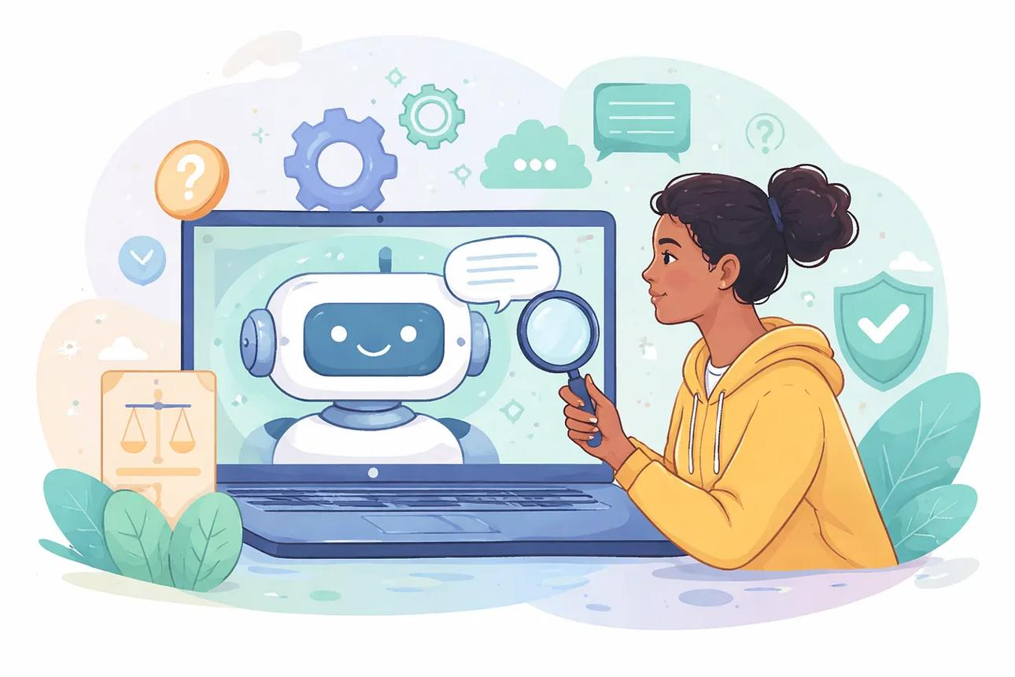
medium.com

1. How does Gen AI Testing work?
Suppose a user asks the AI chatbot:
“What are the common side effects of paracetamol?”
The tester checks the following:

Correctness Testing
Does the AI provide medically accurate information?

Relevance Testing
Does the answer match the user's question?

Safety Testing
Does the AI avoid dangerous medical advice?

Hallucination Testing
Does the AI invent facts or provide information without reliable support?

2. Traditional Testing vs Gen AI Testing
Traditional software testing | Gen AI testing
Checks whether software works as expected | Checks whether AI responses are useful and trustworthy
Usually expects a specific result | May allow multiple valid answers
Example: Login button opens the home page | Example: AI answers a user's question correctly
Checks functionality, errors and calculations | Checks correctness, relevance, safety, bias and hallucinations

3. Real-world example for a software tester
Imagine you are testing an e-commerce AI chatbot.
User asks: “Suggest shoes for running.”
- Positive test: AI recommends suitable running shoes.
- Negative test: User enters an empty question; AI handles it properly.
- Hallucination test: AI invents a product or claims a shoe is available when it is not.
- Security test: User tries to make the AI reveal confidential system instructions.
- Consistency test: Similar questions receive reasonably consistent answers.

4. Why should software testers learn Gen AI Testing?
- To test AI chatbots and AI-powered applications.
- To identify incorrect or invented answers.
- To check whether AI follows instructions.
- To find security and safety issues.
- To verify that AI responses meet business requirements.
Remember: Traditional testing checks whether the software behaves correctly. Gen AI testing also checks whether the AI's answers are trustworthy, relevant, safe, and appropriate.

